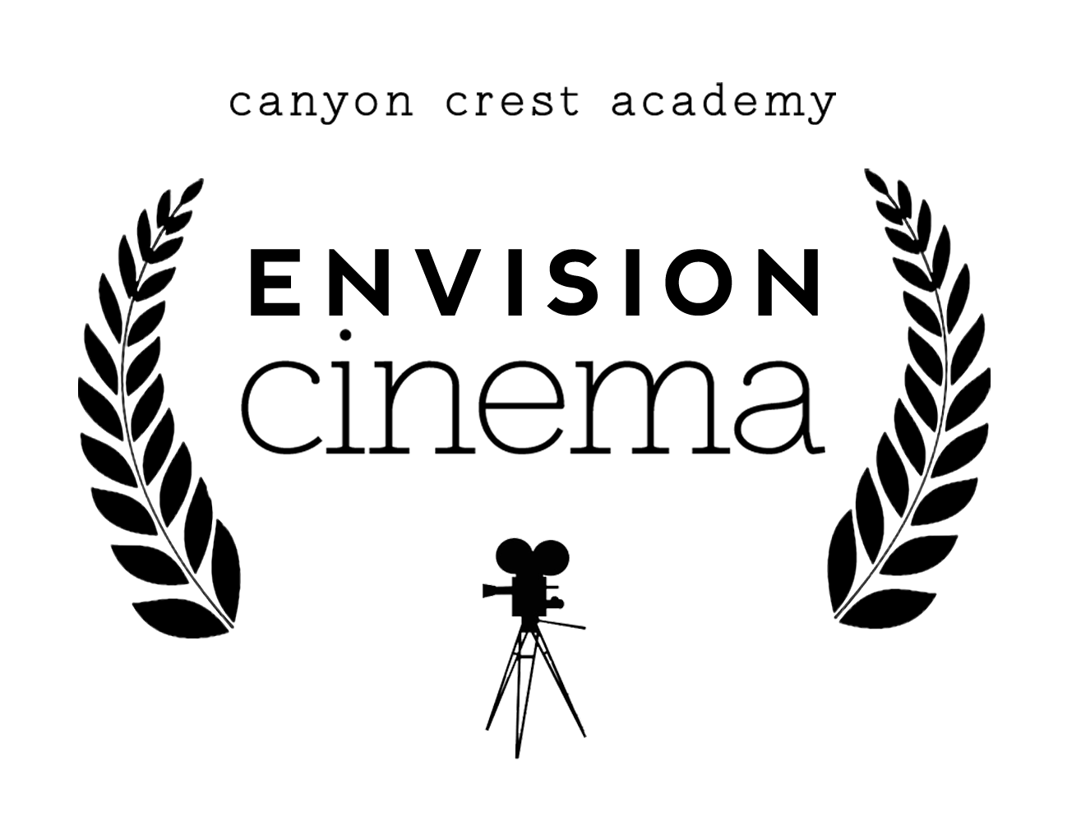

Working Title:

Filmmaker(s):

Primary Location(s) Needed:

List the main characters in your film below and describe their main goals/obstacles.

In 1 paragraph, please explain the story. Be specific on the main plot points progressing the film from beginning to end.

Briefly describe the overall style and feel of the film. Include your personal connection to the story and why you are choosing to make the film.

